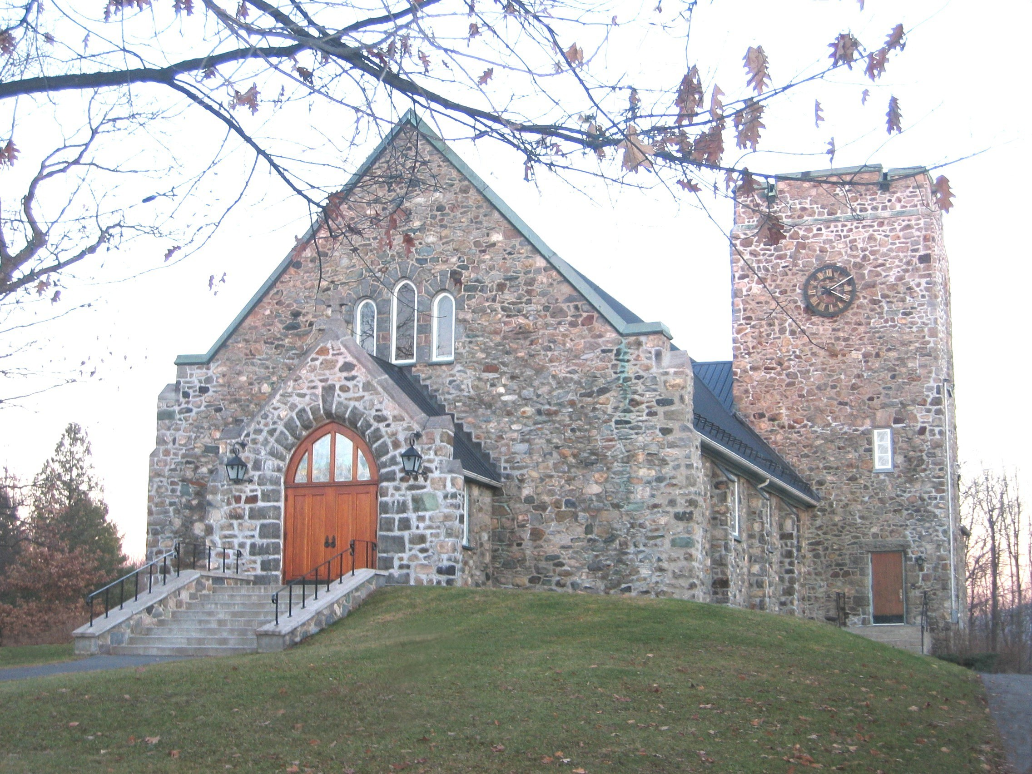

St. Paul’s Anglican Church

24 St. Paul Road

Knowlton (Lac Brome) Que. J0E 1V0

Tel.: (450) 242-2885 Fax: (450) 242-2916

RECTOR

The Reverend Tim Wiebe

RECTOR’S WARDEN

Gary Crandall

PEOPLE’S WARDEN

Glenn Mason

What Kind of Church

is St. Paul’s ?

St. Paul’s Anglican Church, which proclaims Jesus Christ as Lord of the whole of life, is a Biblical church where the Christian Scriptures are read and studied as authoritative for our lives, and a Christian community in which we seek to grow together in the love of Jesus Christ.

Ministries Offered . . .

Bible Studies

Small groups have been meeting weekly to study the Bible since 1984. The number of groups has varied from 2 to 3, with participation normally running from 30 to 40 at any given time. Many parishioners have participated at one time or another. While each group determines its own program and format, accountability is maintained by the Rector.

Sunday School

Our Sunday School has an enrolment of 5 to 10 youngsters under the age of twelve years old. Five teachers follow a program based on the Lectionary (Seasons of the Spirit), on a rotational basis. Sunday School is held in the Church Hall and a Nursery is available for the very young. Our Summer Sunday School features a week long day camp, usually with a curriculum developed locally. Last summer we profited from the “Ministry Challenge Program” which provided a leader subsidised by the Diocese.

The children rejoin our main worship service at Communion and on occasion participate in the 10:00 a.m. service. For this past Christmas Season our Sunday School presented a staged reading with puppets and choir. We are presently forming the children's choir, which will meet every Wednesday evening in the church and on Sundays during our Sunday School sessions. If there is interest we have plans to continue the choir for an Easter presentation.

Youth Ministry

We sadly regret the absence of a Youth Group in our services. Our efforts have been fruitless, however, as a major part of our Parish Vision, it is our desire to see this program revived.

Nature of the Christian Community

at St. Paul’s . . .

While our parishioners come from a rich variety of backgrounds and traditions, there has been no deviation from Anglican creed and liturgy. We typify and value the scope and diversity, which exist within the Anglican communion today.

While many live and work in Knowlton, which is a relatively small and close community, worshippers have been attracted by the Christian message being preached and by the joy and warmth evident in worship services. The Rector and a team bring the Eucharist to the local nursing homes in and around Knowlton.

Our parish regards the appointment of a new Rector/Incumbent as an opportunity to expand the Sunday School, revive Youth Services, and encourage and increase the services to the nursing and convalescent homes as well as to shut-ins. There is a range of feelings regarding the style of worship services offered and there is considerable support for the continued use of the BCP and BAS within our services.

Present Routine of Worship

8:00 a.m. 1st, 2nd, 4th Sunday BCP Eucharist with sermon
3rd Sunday BCP Morning Prayer
Music 1or 2 Sundays a month

10:00 a.m. 1st Sunday BCP Eucharist
2nd, 4th Sunday BAS Eucharist
3rd Sunday BCP or BAS Morning Prayer

Relationship with Local Churches

Within Knowlton there are also United Church and Roman Catholic congregations, with whom St. Paul’s enjoys a cordial relationship. The Rector is a member of the local Ministerial, which meets once a month. The Ministerial also includes the Pastors of the Baptist and Pentecostal Churches of the area. The three Knowlton churches alternate hosting the World Day of Prayer and all participate in ecumenical outreach programs such as the service held last fall at the Brome Fair Grounds.

Basic Statistics . . .

The Parish of Knowlton encompasses the Town of Knowlton and extends into the surrounding region of the Town of Brome Lake, Quebec. We are a part of the Deanery of Brome Shefford and of the greater Diocese of Montreal.

Parish List: 150 (official listing)
90 (considered active)

Attendance: 8:00 a.m. 15 to 25
10:00 a.m. 50 to 70
Sunday School 5 to 10

The Parish formally has a second charge, St. Michael’s & All Angels in Bolton Glen (5 km away). A series of monthly inter-denominational hymn-sings, led by members of the parish, are held during the non-winter months.

Other Details . . .

Rectory

An attractive, two-story, red brick house, circa 1850, (classified in 2002 as an Historical Building) is situated on spacious grounds. The house features a kitchen, dining room, living room with fireplace, TV room (with cable), office, cloak room, 5 bedrooms, 2 bathrooms, a large upper hallway and has a large screened in veranda. The property has a fenced in garden as well as a Carriage House converted into a garage and storage area.

Church

Built in 1941 of local fieldstone, our church is the third St. Paul's to offer a place of worship to the people of Knowlton. Occupying the same site as its predecessors, its stained glass windows, dedicated to the Glory of God and in memory of generations past, add to the beauty of the interior, inviting meditation and quiet reflection. We are a biblical church where the Christian Scriptures are read and studied as authoritative for our lives, and a Christian community in which we are seeking to grow together in the love of Jesus Christ. The church can accommodate 300 people and has ramp accessibility. We are proud of our Casavant organ and a space is also provided for other instruments to enrich our music. Our sound system is excellent.

A small, but comfortable, library cum meeting room provides books for all ages as well as videos and cassettes for the children.

The church basement includes a well-lit meeting hall with a stage, a small but well equipped nursery, and an adequate kitchen.

Office Facilities

The church office, Rector’s office and a library/meeting room are located within the church building. The office is also equipped with a personal computer, a high volume photocopier, fax machine, large screen TV and VCR for workshop and video purposes, as well as an overhead projector.

Parish Staff

The parish employs a part time secretary and a music director. A Coordinator is generally available for the Rector for weddings, funerals, events etc. on an “as needed” basis.

Building Committee

There is an ongoing and long-term refurbishing program for repairs and renovations to our church building and rectory. Members meet on a regular basis to evaluate and determine appropriate actions to keep our buildings in good repair. They also organise a “Work Day” each year. This is an event where the whole congregation can enjoy each others company and look after the smaller maintenance projects.

Continuing Education

There is provision within our budget for continuing education for the incumbent. The Montreal Diocesan College is one hour away.

Prayer Chain

Approximately 11 parishioners are part of an active prayer chain, providing immediate prayer support for people with special needs. This unselfish and dedicated support undergirds all our activities. Members have participated in workshops on prayer and healing.

Mission

St. Paul’s has had active involvement in hands-on overseas mission support since 1985, and supports a Honduras mission through the auspices of the South American Missionary Society (SAMS Canada). Twelve parishioners carried out a two-week mission to Honduras in the summer of 1997.

Music Ministry

The music used within our worship is an equal blend of traditional hymns and contemporary praise songs. Hymns are played with organ, and praise music with guitar, bass and keyboard. The focus of our Praise Team is on congregational participation and joy rather than on musical presentation and performance.

Our 10:00 a.m. service includes a time of musical praise. There is music (organ) at our 8:00 a.m. service on the first Sunday of the month and occasionally more often.

Marriage Preparation

Marriage preparation is mandatory for all those who wish to be married at St. Paul’s and is the responsibility of the Rector.

Parish Council

The Parish Council is made up of 10 members elected from the congregation and meets with the Rector on a monthly basis. Each year three members are replaced at Vestry. The purpose of the PC is to implement the Vision that God gave us in 1998. The council serves as a sounding board and as a support for the corporation. Its responsibilities range from helping to implement various programs and organising events, to keeping communication lines open within the church and the community.

Age of Wisdom

This is a group of parishioners over the age of 50 who meet occasionally through various events and excursions. Their primary purpose is to provide social contact.

Mission and Parish Development Days

St. Paul’s has held missions both within and outside the parish on an irregular basis, featuring Bishop Harding of ARM, Bishop Eddie and Emma Marsh (in conjunction with Trinity Church, Cowansville). Bishop Michael Pountney and his team led the ecumenical “Come and See” Conference. Seven denominations participated in the March For Jesus here in Knowlton. Most recently Canon Brian Pearce has conducted “Pastoral Care” workshops at St. Paul’s.

Lay Leadership

There is considerable lay involvement at St. Paul’s. Lay participation prior to our services includes Altar Guild and Flower Guild; within the services, it includes Servers, Musicians, Prayer Leaders, Chalice Bearers, Readers, a licensed Lay Reader, and Sidespeople. Outside of our worship service lay leadership manifests itself in the form of individuals leading Bible Study groups, participation on Corporation, Parish Council, Church Cleaning Team and numerous other committees.

Other Church Activities

Aside from the various activities and ministries listed previously, St. Paul’s features a number of other activities designed to foster a greater sense of Christian Community. Although, now officially disbanded, several of the former ACW ladies are still active with fund raising such as Rummage Sales with proceeds going to the Building Fund. Pot-luck dinners, parish picnics and annual workdays also occur.

Parishioners assist in the Breakfast Program at Knowlton Academy and there is good participation in Christian activities outside the Parish including Sisters of Mary Retreats, FLAME, AWARE, and Marriage Encounter weekends. Parishioners have also participated in and led ALPHA Programs, Education for Ministry and an outreach program to the Cowansville Prison, in conjunction with other churches.

Relationship with other Anglican Parishes

The clergy of the deanery hold a bi-weekly clericus in each other’s parishes, while Deanery Chapter meetings with clergy, wardens, and treasurers are held quarterly. Parishes take turns in hosting these events. Efforts are also made to arrange transportation to attend special events. Parish missions and quiet days are open to all.

Challenges

St. Paul’s has participated in a visioning process and a copy of the results is attached and forms part of this document.

Goals

Our goal is to implement the Parish Vision by means of the Covenant between the Diocese of Montreal and this Parish.

A Vision of St. Paul’s in the Year 2008

St Paul’s is a vibrant, loving community, committed to the Lord Jesus Christ, and acknowledging the sovereignty of God in all our activities. The presence of the Holy Spirit in our lives provides a beacon of light for the surrounding region. We have grown through acknowledgement of our failures and hurtful divisions and our subsequent repentance.

We value our differences, and the ability to resolve our conflicts. We respect our members’ diversity by providing both traditional and contemporary praise services, rejoicing that God has added to our numbers in a significant way.

God’s light is shining into our community. Our neighbours value our presence as we respond meaningfully to people in need, particularly youth, families, and seniors. Our focus on mission in Central America is shared by the local community, who now joins us in supporting this outreach.

Jesus nurtures and strengthens our members in their faith, and equips them to carry out their ministries. A significant portion of our congregation is involved in Bible Study and similar small group activities, fellowship, and prayer ministry. We have many competent lay leaders whose gifts are fully utilized. While we emphasize family ministries, singles of all ages also feel at home. Our parishioners are grateful to God for His many blessings arid respond generously in many ways.

One of these blessings is our outreach to local youth through special worship services and activities. We have a thriving Sunday School with the necessary adult leadership. God’s love is shared with local children through several other programs.

All of these activities have required improvements to our church halt and kitchen, and have led us to consider possibilities for expansion. Financial support from our members has made it possible to consider this seriously, and we have regular budget surpluses. We are thankful to God for His abundance.

Nature of the

Local Community . . .

Knowlton is a rural community of about 5,000 people, located in Quebec’s picturesque Eastern Townships, one hour’s drive east from downtown Montreal, and 25 minutes from the Vermont border. The town itself is located on the shores of Brome Lake, and at the heart of the townships’ alpine skiing region.

With its attractive natural setting, and the restoration of its inner core, Knowlton has become a popular year round, tourist centre and is experiencing growth. Most parishioners work in surrounding communities, i.e.: Cowansville, Bromont, Granby, Magog, and even Montreal but live in Knowlton or the immediate area. A number of other parishioners are part time residents who spend their weekends and summers in the community.

The area is an excellent place for youngsters to grow up in, and offers a highly attractive lifestyle; the availability of the lake and countryside in the summer, and skiing during the winter. There are several golf clubs, a boat club, pony club, indoor squash and tennis club, and a public beach all within the town itself. The town also boasts community theatre, a community concert band, Canada’s oldest public free library, and has a delightful country museum situated in a park across the street from the Rectory.
English and French elementary schools are both available within the town, while high school students are bussed to Massey-Vanier High School in nearby Cowansville (20kms away). There is an off-campus centre of Bishops’ University in Knowlton offering credit courses.

There are medical and dental clinics in Knowlton, as well as excellent hospital facilities in Cowansville and Granby. The service of First Responders is available 24 hours a day. There are two nursing homes and a total-care geriatric centre in town. There are also seven universities within a ninety-minute drive.

http://montreal.anglican.org

